**July 2024 Parish Report**

There were a lot of commemorative Sundays to celebrate in July and this had kept the Liturgy Committee busy leading up to this month. The committee always looks to find meaningful ways of commemoration which highlight the purpose of the day, while enriching our liturgies. The first was Aboriginal and Torres Strait Islander Sunday on the weekend of 6 and 7 July. In this instance, the committee was guided by the National Aboriginal and Torres Strait Islander Catholic Council (NATSICC). Committee member, Jim Finlayson spoke to a First Nations Person about having a smoking ceremony for when people enter the Church. Our immediate problem at Sacred Heart was the danger of triggering the fire alarm in the narthex (porch). Then there was an issue of cost to have a First Nations person doing the ceremony at all the Masses, and also the purpose – and using the information from the Wurundjeri Corporation - would it work in our context? They state:

“For thousands of years we have employed Smoking Ceremonies to cleanse places and people  of bad spirits to promote the wellbeing of our people as well as guests on Country… For full participation, those present will typically be invited to walk through the smoke for an individual cleansing.”

With all this in mind, the Committee decided to forgo the smoking ceremony. However, the use of the Message Stick has strong parallels with our faith culture – the purpose of it to convey important messages. Thus we used this in procession with and when reading the Sunday Gospel – our Good News. There were other images, prayers and hymns which would sit within our liturgy – a Sprinkling Rite replacing the Penitential Rite; singing the Aboriginal Our Father; using wonderful spiritual art images on the mass slides, use of Indigenous-designed cloths and carpet; use of a coolamon to bring up the bread in the offertory procession; use of First Nations flag-decorated candle holders, a special reconciliation prayer, statistics and information from the NATSICC’s booklet.

Sea Sunday was next and we have three parishioners who are dedicated volunteers with Stella Maris, the largest organisation that provides pastoral care, services and support. The Liturgy Committee once again called on parishioner and volunteer, Christina Siciliano to give us some insight into the wonderful work of care and compassion to strangers who come to our shores. Christina encouraged us all to pray for those strangers, often poor people seeking to make a better life for their families but in danger of working in atrocious and often, dangerous conditions. Christina invited all to come along to the Stella Maris centre on one of their tours to the port.

On Grandparents and Elderly Sunday, the committee thought it would be beneficial to have some words directly from some of our ‘elderly statespeople’, our wisdom holders, on the joys and challenges of ageing, specifically, ‘What has kept them going all these years?’ Shirley Cheet at 9.00 a.m. Mass spoke of the love for her grandchildren who have brought her such joy, as did Helen Richards at our 6.00 p.m., Mass who spoke of learning and inspiration from her grandchildren. At the 11.00 a.m. Mass, wisdom imparted to us by Giuseppina, aged 99 years and 5 months was: ‘Live well, mix with others, prayer is essential, learn to forgive so you can move on in life and go to bed with a calm heart’.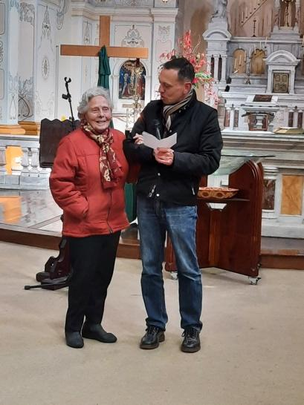

*(PTO)*

As you can see the Liturgy Committee is very active in seeking to enrich our Sunday liturgies with the use of image, prayer, speakers, symbols and music, generally and around specific themes. The members have diverse gifts which lead to much creativity in expression. The committee is open to new members and if this interests you, come and have a chat to one of us: Melanie Williams, Jim Finlayson, Silvana D’Ambrosio (Sacred Heart); and Ancita Beale (St Columba); or Fr John and Christine.

This month parishioners and members of the PLDT joined in the excitement of the launch of Sacred Heart Mission’s new Strategic Plan to guide them over the next six years. Fr John provided the welcome reflection. Before he spoke, First Nations woman, Jolpin Galpin welcomed all to country. One of the things she stated was the importance of ‘deep listening’, stating that Sacred Heart has shown how essential this is to problem-solving the complexities which they face in all aspects of their work. By coincidence, Fr John also spoke of ‘deep listening’ (and paraphrasing) - in listening to others, we are made whole. If you go to the website of the Mission (sacredheartmission.org), you will see that ‘deep listening’ is a cornerstone of their approach in serving others in need. Their launch is also on their website for those interested in viewing it. Later in the month, CEO Hang Vo came and spoke to St Columba School Advisory Council, with a member of the PLDT also attending, as we strive to sew greater threads between our three organisations.

Work on the ground this month included many visits to hospitals, hospices, personal and aged-care homes by Fr John, Legion of Mary, community visitors and parish staff members. Some older, active members have become quite frail. Our visits have been frequent as a show of ongoing love and support – just because they are not in the pews does not mean that we have forgotten them.

We had a number of funerals of both Mission and Parish, which necessitated Fr John to move around, several times, his annual retreat. Finally he exited the parish for a few days of intense spiritual nourishment (and rest!).

Those baptised or confirmed into our faith at the Easter Vigil held a reunion dinner and shared their continued excitement of being part of our faith tradition. One person stated that she has not missed one Mass since she became a Catholic! With one exception, we do not see these people in our masses as they came from outside our parish to prepare for their baptism. In the RCIA (Rite of Christian Initiation), a parish is an essential part of the process, where people feel welcomed and supported and find a place to belong. Arguably, we do this well, however, this pattern of those coming to us from outside points without laying roots points to an increasing trend of ‘parish shopping’ and ‘Mass hopping’. While we would never force anyone to attend our Masses on a regular basis (as seen in some parishes), it’s an issue which requires more thinking and ideas.

July ended in great celebration with our social and fundraising event: ‘Soup A Sweet’. Around forty people gathered on a cold Sunday afternoon for a warming lunch and friendly connections, which raised money for our parish. A sum of almost $1640 was raised, a large part of that being a generous donation. It was great to see new parishioners, friends of parishioners, those we have not seen for a while all mixing in and having fun. Another great event organised and hosted by our Social Committee, for which we give thanks!